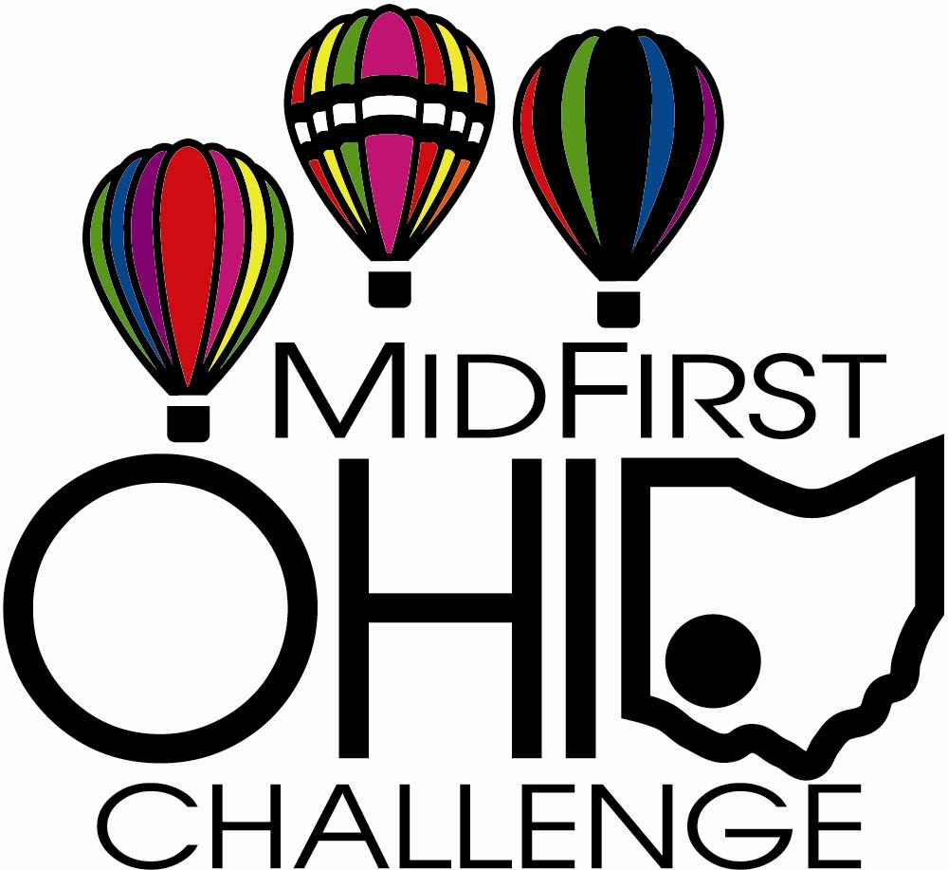

2007 MidFirst Ohio Challenge
Schedule of Events –
July 20-21-22, 2007

Pre-Event:
Balloon practice flights
Skydiving Training Jumps
Tandem Skydiving Jumps with area VIPS

Throughout the weekend:
Indian Village Display
Kids Discovery Center
Leap to Learning Skydiving Discovery Center
Arts & Crafts
Murray Brothers Carnival
Festival Foods
Special Shape Balloons Fred B Rabbit and The Rocket join each balloon flight
Baker Bowl Skate Park
Playground/Splash Pad
Skydiver Simulator Wind Tunnel Ride

Friday
9 am-5 pm Airplane Rides
4:00 pm Park Open/ $1 Adult Walk-In Admission (12 and under free) OR $5 On-site Parking
5-7:00 WPFB, 105.9 The Rebel broadcast from site
6:00 Opening Ceremonies
National Anthem –
Recognition of Sponsors and Elected Officials
Presentation of Colors
Team Fastrax – Bringing in the
7,500 sq ft American Flag
6-7:00 The Doug Hart Band – Blues/Rock
7-8:00 Balloon Launch from Site
(weather permitting)
8-10:30 Slowhand – Eric Clapton Tribute Band
9-9:30 Balloon Glow
9:30-9:45 Team Fastrax – Night jump with pyrotechnic display
10:30 Park Closes

Saturday
7:00 am Balloon Launch – Fly into festival site (gates open/free admission/parking)
7:00 Registration for 5K Race
8:30 5K Race – Sponsored by Middletown High School Athletic Boosters
9 am-5 pm Airplane Rides/Helicopter Rides
Noon Park Open/ $1 Adult Walk-In Admission (12 and under free) OR $5 On-site Parking
1:00 Team Fastrax – Skydiving Demonstration
2:00 Team Fastrax – Skydiving Demonstration
2:00 Geocaching Demonstration and Hunt
3:00 Team Fastrax – Skydiving Demonstration
3-5:00 Cold Air Inflated Hot Air Balloon
Walk Thru/ $1 donation to charity
4:00 Geocaching Demonstration and Hunt
4:00 Team Fastrax – Skydiving Demonstration
4:30-5:00 Ohio Cardinal Cloggers
5:00 Team Fastrax – Skydiving Demonstration
5-7:00 WPFB, 105.9 The Rebel broadcast from site
5:30 Thank You Foundation Awards
Certificates to American Veterans
5:45-7:00 Daniel Smith - Country Music
6:00 Team Fastrax – Thank You Salute to Veterans – 7,500 sq ft Flag Jump
7-8:00 Balloon Launch from Site
(weather permitting)
8:00 Team Fastrax – Skydiving Demonstration
8-10:30 Midnight Special – 70’s Rock
9-9:30 Balloon Glow
9:30-9:45 Team Fastrax – Night jump with pyrotechnic display
10:30 Park Closes

Sunday
7:00 am Balloon Launch – Fly into festival site (gates open/free admission/parking)
9 am-5 pm Airplane Rides/Helicopter Rides
10:00 Car Show Registration
Noon Park Open/ $1 Adult Walk-In Admission (12 and under free) OR $5 On-site Parking
12-4:00 Classic Car Show
12-2:00 Corky’s Rock and Roll Review –50’s Music
2:00 Team Fastrax Skydiving Demonstration
2:00 Geocaching Demonstration and Hunt
2:30-4:00 The Rebel/105.9fm Broadcast from Site
2-4:00 Timeless Country Music Band
3:00 Team Fastrax Skydiving Demonstration
3-5:00 Cold Air Inflated Hot Air Balloon
Walk Thru/$1 donation to charity
4:00 Car Show Awards Presentation
4:00 Geocaching Demonstration and Hunt
4:00 Team Fastrax Skydiving Demonstration
4:30 -7:00 Joe Hedges Modern Rock Band
5:00 Team Fastrax Skydiving Demonstration – Water Jump
7:00 Balloon Launch from inside Smith Park (weather permitting)
8:00 Park Closes

Updated 6/25/07

